**Big Mountain Resort Findings**

After looking through the data and evaluating a couple models to look at ticket prices as well as ways to cut costs with the ultimate goal of increasing revenue the following areas stood out.

Currently we are charging $81 for a weekend ticket. Based on modelling we should be charging $94! Even allowing for the possibility of error with our model there is sufficient evidence for a higher ticket price.

An area where we could stand to grow and gain more value in the market is vertical drop:

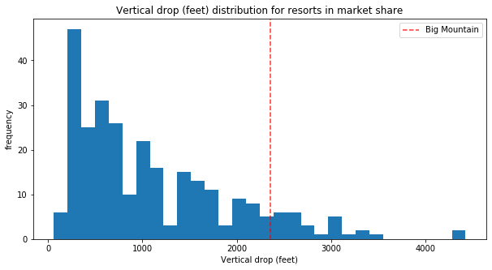

Here it is plain to see that there are resorts with a higher drop than us. Modelling shows that customers place high value in this.

Right now we also have higher costs than we need to. Closing a run would actually not impact our revenue at all:

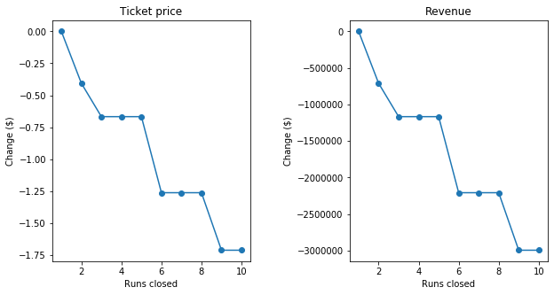

Closing more than 1 run would begin to lower revenue but 1 run at our current amount of runs makes no difference.

Based on the data provided the best move to increase revenue appears to be adding a run that increases our vertical drop by 150 feet and only requires one more lift. This would justify a ticket price increase of $1.99 and result in over $3.47 million dollars in increased revenue!

I hope the information presented here helps you see that there are easy steps that you can take to instantly take more advantage of your existing facilities and even increase revenue in a very simple and gratifying way.